Chang-Min Hwang  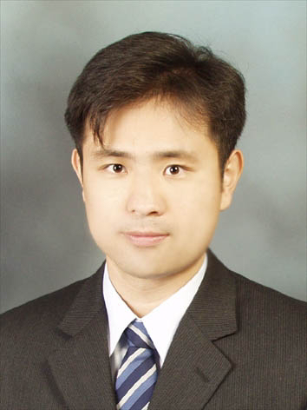 | #103-502 DAEWOO MIRESARANG  DANGSAN-dong  Youngdungpo-gu, Seoul   Phone: (02) 678-5837  Cell Phone: 011-9348-0822  Email: hcm0822@empal.com

Personal Details:

- Date of Birth: 22 August 1976
- Nationality : Korean
- Sex: Male

Highlights

- Work well both independently or as part of a team
- Excellent inter-personal and communication skills
- Honest and reliable
- Computer literate
- Genuine and friendly
- Can speak English and Korean fluently

Education/Training

- Graduate in Business Management
Hong-Ik University 1996~2002

Primary subject GPA
Marketing A
Statistics A
Business Management Strategy B+
Marketing management B

Basic/Financial /Cost Accounting, Acounting theory B+, A , A, B+
Finance, Investment theory, Finance analysis/seminar A, A, B+,B
Total GPA 3.58/4.5
Graduated Dae Young Middle & High School
1992-1995

Work History

Finance Department in DCC chemical.co
- Experienced in note receivable / payables in A/P, A/R
- Payment with various methods
- Cash-flow forcasting, management and modeling
- Borrowing, Loans, Coporate bond management
- Deposits, Government bond management
- Journal creation, closing, auditing Related in finance team
- Reports about profit & loss, Monthly finance status

Support Officer
Korea Management Association(6month)
- Revised home page of various companies
- Skilled in prioritising tasks in order to ensure deadlines are met
- Completed other general office administrative duties as required
- Data entry experience

Tour Co-ordinator
Osan Air Force Base (9month)
- Assisted with Interpretation for American Military Personnel
- Effective customer service experience

Overseas Educational Experience

- English Language Course – Washington State University 2002

Military Service

- 1998.3.24~2000.5.23(discharge on expiration of term of service – a sergeant in the army)

SELF INTRODUCTION

I wish to apply for a position as advertised. I believe career at your company fits very well with my education, experience and career interests.

Through elementary school to high school, I was very active in representing and in showing leadership for the class. I had numerous opportunities to lead my class as my class members elected me as a class representative and I believe that this experience has had an impact on my outgoing personality and positive outlook on life.

During the military service, I had the chance to work in the accounting unit. I remember returning my annual holiday in order to finish the assigned work. This incident indicates that I take responsibility for any task assigned to me.
After returning to university from the military service, I became interested in accounting. So, I began attending all the accounting, business administration/ finance classes offered by the university.

I have graduated from Hong-Ik University in 2003 with a B.A. degree in business administration/management. When I studied these subjects, I studied focusing on the Korean business environment, also taking into account problems shared commonly by most Korean companies.

My studies have included courses in finance/accounting, statistics and
marketing/strategies. Taking these subjects has strengthened my enthusiasm and interest in focusing my career on finance. As a statistics project, I wrote an essay on how the changing weather has an effect on the sales of different menu items at a Chinese restaurant and also revised a business plan for the business strategy course. In addition, I also worked for the Korea Management Association under the direction of the Professor of Management Information System at Hong-Ik University.

I understand the position also requires a candidate who is team- and detail-oriented, works well under pressure, and is able to deal with people in departments throughout the firm. These are skills I developed both in my course work and in my recent work experience at Osan Air Force Base and in finance team. Further, I believe the position at your firm requires excellent communication skills. During my fourth year at university, I took an opportunity to work as a part time tour guide in O-san Air Force Base assisting military personnel. This experience greatly enhanced my English level, in particular, English communications skills.

Since joining the company in March 2003, I have taken responsibility in Account receivable(note receivable), account payable(note payable) dishonored check with Oracle ERP. My responsibilities further extended to taking charge in monthly closing, quarterly, annual audit. and forecasting monthly and daily bill collecting.

After carrying out the above mentioned tasks for a year and a half, Daily I am currently managing daily cash flow, current deposit records, bill collecting to current deposit from 136 bank books, issuing a check, money execution, commercial paper, MMF receipts. Journal creation about above mentioned works.

Monthly tasks include identifying borrowing, loans, corporate bond schedule, interests management, registering them on TR. Also profit & loss closing, valuation, deposits closing, government bond management, liquidity transferring involved.

Now I have taking about raising funds and reporting profit & loss, Monthly finance status.
I am confident that my existing qualities and personal experience make me an ideal candidate for a position at your firm. I believe I can perform the job effectively, and I am excited about the idea of working for a dynamic, recognized company.
I am certain that my academic background and work experience will be of an asset to your organization.

I look forward to an opportunity to meet with you for an interview.

Yours sincerely,

Chang-min Hwang

