R E S U M E
( Application date : 2009. 05. 24)
Basic Info. |  |  |  |  |  |  |  |  | Photo  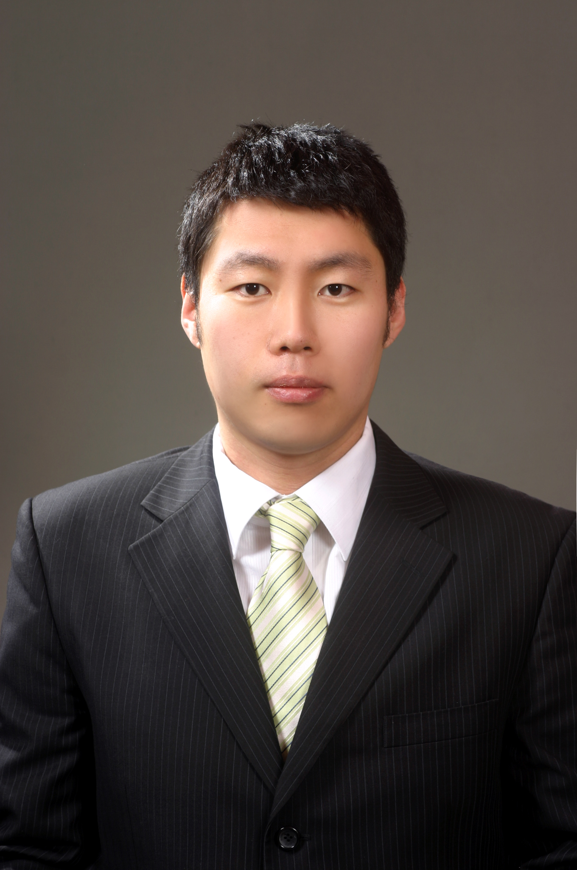
Name | (Korean) | 정문형 |  | Resident  Registration | 840117-1064017 |  | Age | 26
Name | (Chinese) | 鄭文亨 |  | Patriots/  Veterans | No |  | Mobile  Phone | 010-9797-7168
Current Address |  |  | #202 316-169 Sadang4-dong, Donjak-gu, Seoul, Korea
TEL | 02-2183-1884 |  |  |  | E-Mail | moonhyung@gmail.com

Career history [ Total Career : year(s) month(s) ] |  |  |  |  |  |  | Desired Job / Language ability
Period |  |  |  |  | Company & Dept.or Team |  | Desired | Dept. | Position
Year | Month | - | Year | Month
2008 | August | - | 2009 | May | SKC / Optical Film |  | 1st. Job | Marketing | Associate | Market Analyst
2006 | May | - | 2006 | October | UL Korea / Quality |  | 2nd. Job | Brand Managing | Associate | Brand Manager
 |  | -
 |  | - |  |  |  |  | Language | TEST Name | Record / Level | Date
 |  | - |  |  |  |  | English | TOEIC | 965 | March 30th 2008
 |  | - |  |  |  |  | Japanese | JPT | 375 | December 14th 2008

Educational Background
Period |  |  |  |  | Name of  High School/ College/ Univ. | Major | Average  Record  (5.0 Conversion) | Location | Remark
Year | Month | - | Year | Month
2007 | Sep | - | 2008 | July | NEGOCIA | Marketing | 4.2/5.0 | Paris
2002 | March | - | 2007 | July | Ajou University | Business Adim. | 4.3/ 5.0 | Suwon
 |  | -
 |  | -
ㆍ Blank period / Reason (Before / after graduation)
ㆍ Double major / Sub-major, etc.

Military service / Personal Info. |  |  |  |  |  |  | Certificate / License
Section | 1.Completed |  |  |  |  |  | Name | Level | Institute
Army | Marine | Class | Staff Sergeant | Period | 02.2004~02/2006 |  | Information Processing Technician | 2 | HRD Korea
Any handicap  of health & body |  |  | ( Handicap grade : ) |  |  |  | Microsoft Office Specialist | Master | Microsoft

Family Info.
Relation | Name | Age | Educational background | Job | Company | Title | Residence | Live together or not
Father | Inhwa Jung | 55 | High School | None |  |  |  | No
Mother | Jungyun Jo | 55 | High School | None |  |  |  | No
Brother | Moonho Jung | 24 | University | Student |  |  |  | No
Career Introduction
(Application date : 2009. 5.24)
Ⅰ. Applying motive & Vision | Applicant : Moonhyung Jung
Applying motive
With my specialized background in marketing and my various experiences, it is certain that I can make a strong contribution to your organization.
I attended a master program of NEGOCIA which is a business school in Paris focusing on studying about international marketing. I analyzed the actual market demand by looking through statistical data and created a brand new concept to penetrate the market.
In UL Korea Quality department, I analyzed the key performance data of employee in all of the affiliated countries. I made the data meaningful and recognizable by using a variety of tools so that senior mangers were staying aware of the quality of services.
Recently in the Optical Film department of SKC, I have been analyzing market demands, target markets and competitors in order to see the trend of optical film market and to find the future needs.
My experiences in those positions, combined with courses in NEGOCIA, have convinced me that taking a marketing related job in a larger conglomerate is a career option I would like to explore.
Vision
In recognizing the priority of this position, I would have to declare the following three tasks will be done by me:
First, analyzing of market demands and target customers will be accomplished. Using previous experiences in SKC, I would find out the detailed information of dealers, retailers and end users in terms of expected sales amount and such in order to stretch the market share.
Second, activating the SWOT analysis and other tools, I would dig into the data to know the customer needs so the core competency of products can be set. Using the experience of developing new concepts in various markets in the business school, I would be leading the production team and the advertisement team for them to recognize the needs.
Third, by harnessing the ability of building relationships with work related parties, I would be creating more opportunities to look out more objective data and to collect more accurate data. With on-line and off-line survey, senior managers will realize the real situation of market in terms of calculated numbers.
I am ready to devote my full ability for making your company a more efficient organization.

Ⅱ. Career details
Period |  |  |  |  | Company & Dept.or Team  Month | Job title | Role & Responsibility | Reason  to leave
Year | Month | Year | Month | Year
2008 | August | 2009 | May |  | SKC Optical Film  10 months | Marketing & Sales Representative | Analyzing market demands | Currently working
2006 | May | 2006 | October |  | Underwriters Laboratories | Quality Team Associate | Analyzing the key performance data | For study

Ⅲ. Job related training
Period |  |  |  |  | Training details | Provided by
Year | Year | Year | Year | Year | Training details | Provided by
2008 |  |  |  |  | Investment Strategy | NEGOCIA
2007 |  |  |  |  | Global Leadership Program | Ajou University

Ⅳ. Competitive knowledge & Skill / Strength & Weakness / Key Achievement
(1) Competitive knowledge & skill |  | Applicant : Moonhyung Jung
Section | Details
Research/  Survey /  Analysis | Excellent knowledge in Pivot Table and Formula of Spreadsheet  Information Processing Technician 2nd grade  Microsoft Office Specialist – Master Certificate  Diversified analysis plans and developing presentations in SKC
Management  / Training  /Organizatio-nal Ability | Managed daily activities of selling products (Forecasting, Sending samples, Invoicing, etc.)  Performed sales related duties ranging from attending meetings to presenting products  Organized and prepared 10th anniversary event of UL Korea
Communica-tions /  Language  /Creative  Projects | Bilingual in English and Korean (TOEIC 965)  Basic proficiency in French and Japanese  Created multimedia presentation using slides, music, and narration to brief senior manager or customers

(2) Strength & Weakness / Key achievement
Section | Details
Strength | One of my strengths is the confidence which makes me believe that I am able to complete the assigned task. Even with many obstacles, I manage various tasks simultaneously and communicate with others efficiently in order to achieve a goal. In SKC, the success of selling new products to Samsung Electronic Co. at the first time resulted from the confidence.
Weakness | One of my weaknesses was ignoring other opinions. In order to improve the weakness, I had tried to build effective teamwork with other co-workers in SKC so I recognized the way of absorbing other opnions and keeping the balance.
Key  achievement | In SKC, there are following key achievements that I accomplished.  - New product launching and selling to Samsung Electronic Company  - Sales increase for Funai by using pricing strategy  - Expanding Japanese customers (Sony, Sharp, TMD, etc.)

