Lee Yoon Jung

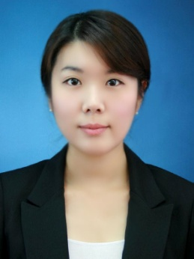

[leeyoonjung.lee@gmail.com](mailto:leeyoonjung.lee@gmail.com)

Z20, Plot no.75, villa no.1, Mohammed Bin Jayed city, Abu Dhabi, UAE

24th of July 1985

+971 56 755 7483

056-755-7483

**Marketing Assistant Brand Manager**

Career Objective

As a fresher candidate, I know my priorities. However, I will learn the different and new things which are pertaining to my job. I will hone my skills along with my work by implementing them. This will help me to gain popularity in my company.

Major Competencies

• Strong aptitude for project deadlines • Conscientious team collaboration skills

• Excellent attention to detail • Proactive multi-tasking and problem solving skills

Technical Aptitude

• Microsoft Office Suite 4 years: Advanced

• MYOB 1 year: Beginner

Qualifications

2007 – 2011 BACHELOR OF ACCOUNTING *Macquarie University, Sydney Australia*

Professional Overview

April 11 – July 11 TELEPHONE SURVEY OPERATOR FedEx, Sydney

Overview• Provided courteous customer service

• Making a phone call to previous customer who used FedEx service within 5 weeks

• Managed all Asian customers by using my language skill

Key Outcomes • Completed the customer satisfaction survey before leaving the centre

• Gained accurate response from customers

Jan 08 – July 11 SALES ASSISTANT / CASH OFFICE CLERK Woolworths, Sydney

Overview• Provided courteous customer service

• Respond promptly to customer needs and questions

• Perform price checks as needed and restock returned or abandoned products in a timely manner

• Adhoc duties as prescribed by the manager

Key Outcomes • Have amazed customers with consistent and friendly service

• Promoted to Supervisor after 1 year in cash office

June 06 - Jul 07 ENGLISH TEACHER ABC English Instituion, Korea

Overview• Teaching basic grammar, reading, listening, writing and speaking

• Assisted foreign teachers in adjusting to Korean culture

Key Outcomes • Significant improvement in students’ level of English

Memberships and Personal Development

2011 Graduate Development Program

*Macquarie University, Sydney*

2010 Macquarie University Student Association

*Macquarie University, Sydney*

2009 Student Member

*CPA Australia*

Interests

Keen, competitive swimmer

Entertaining family and friends at home with Italian cuisine

Tennis

References

Provided on Request