R E S U M E
( Application date : 02 03. 2013 )
Basic Info. |  |  |  |  |  |  |  |  | 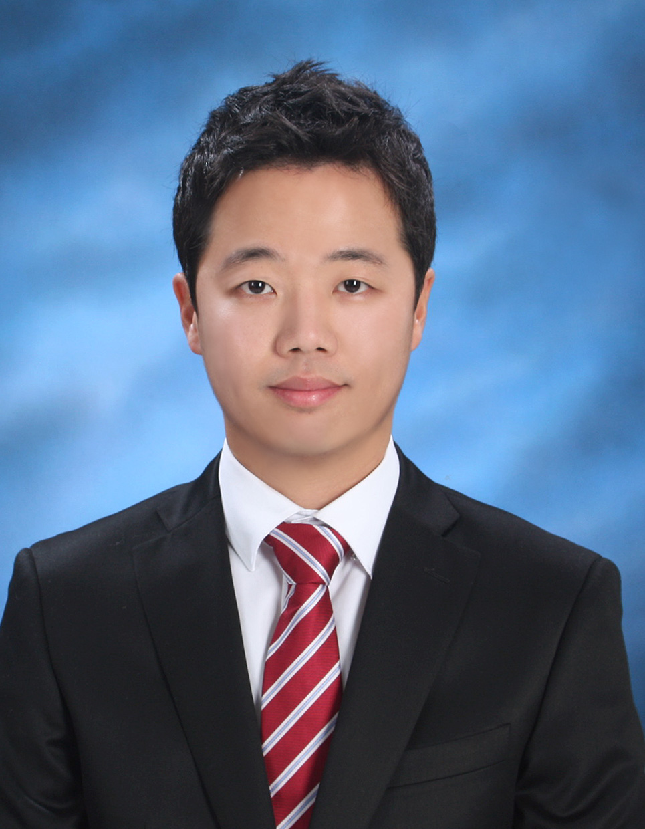
Name | (Korean) | Choi, Minkun |  | Resident  Registration | 801230-1056319 |  | Age | 32
Name | (Chinese) | 崔 民群 |  | Patriots/  Veterans | 1.Yes 2. |  | Mobile  Phone | 010-4367-1230
Current Address |  |  | Sinjeon 1Dong 1052-29 Yangchungu, Seoul, Southkorea
TEL | 02-2652-8001 |  |  |  | E-Mail | snakid@hotmail.com

Career history [ Total Career : year(s) month(s) ] |  |  |  |  |  |  | Desired Job / Language ability
Period |  |  |  |  | Company & Dept.or Team |  | Desired | Dept. | Position
Year | Month | - | Year | Month
2012 | 03 | - | 2012 | 08 | LG Electronics GmbH & Car EU Office |  | 1st. Job | Business Planning | Assistant Manager
2010 | 08 | - | 2011 | 03 | Sammi Heat Industy & Business planning |  | 2nd. Job | Sales Planning | Assistant Manager
2004 | 01 | - | 2004 | 08 | Sammi Heat Industry & Sales
 |  | - |  |  |  |  | Language | TEST Name | Level | Date
 |  | - |  |  |  |  | English |  | Semi-fluent
 |  | - |  |  |  |  | German | DSH | native | Oct. 2005

Educational Background
Period |  |  |  |  | Name of  High School/ College/ Univ. | Major | Average  Record  (5.0 Conversion) | Location | Remark
Year | Month | - | Year | Month
2005 | 07 | - | 2011 | 11 | University of Cologne | Business administration | B:3.17/M:3.4 | Germany | Graduation Diplom  (Bachelor + Master degree)
1999 | 03 | - | 2003 | 12 | Hankuk University of Foreign Studies | German | 3.88 | Korea | dropout
1996 | 03 | - | 1999 | 02 | Yangchun High School |  |  | Korea | Graduation
 |  | -
ㆍ Blank period / Reason (Before / after graduation)  ㆍ Double major / Sub-major, etc. |  |  |  |  |  | Major: Corporate finance, Management accounting, Statistics

Military service / Personal Info. |  |  |  |  |  |  | Certificate / License
Section | 1.Completed 2.Incompleted 3.Exemption (Reason: ) |  |  |  |  |  | Name | Level | Institute
Army | Army | Class | Transpotation | Period | 03.2000∼  05.2002 |  | Driver´s license | Class 1 | Seoul Metropolitan Police Agency
Any handicap  of health & body |  |  | No ( Handicap grade : ) |  |  |  | Taekwondo | 1.degree | Kukkiwon

Family Info.
Relation | Name | Age | Educational background | Job | Company | Title | Residence | Live together or not
Wife | Jeongwon, Hwang | 32 | Graduated from college | Housewife |  |  |  | Yes
Career Introduction

(Application date : Feb. 03. 2013 )
Ⅰ. Applying motive & Vision | Applicant : Minkun Choi
Applying motive

Canon stands shoulder to shoulder with is the world´s greatest corporation.
At Canon, I am sure I will continuously utilize and develop my abilities and carrier as a global leader.
I believe that this chance is worth to invest my future, because Canon stands shoulder to shoulder with is the world´s greatest corporation.

Vision

As a mighty global player, I will be a canon´s master and lead the Canon to No.1 enterprise in the world.
Fast and surely, I will be the important asset and future to Cannon.
I will make Canon as a global No.1 Company, which no real barrier between enterprises and countries.

Ⅱ. Career details
Period |  |  |  |  | Company & Dept.or Team  Month | Job title | Role & Responsibility | Reason  to leave
Year | Month |  | Year | Month
2012 | 03 | - | 2012 | 08 | LG Electronics GmbH  & EU Car Office | Marketing and Sales Assistant manager | Marketing and Sales for VW and Hyundai/Kia Motors | Return to Korea
2010 | 08 | - | 2011 | 03 | Sammi Heat Industry | Management accounting Assistant Manager | Analysis and plan of finance structure | Finish the Master´s thesis
2004 | 01 | - | 2004 | 08 | Sammi Heat Industry | Business support Assistant | Business and sales support | Studying abroad

Ⅲ. Job related training
Period |  |  |  |  | Training details | Provided by
Year | Month |  | Year | Month | Training details | Provided by
2012 | 03 | - | 2012 | 08 | develop new OEM business in Europe | LG Electronics GmbH EU Car Office
2010 | 08 | - | 2011 | 03 | Business planning and management of the finance structure | Sammi heat Industry

Ⅳ. Competitive knowledge & Skill / Strength & Weakness / Key Achievement

- Competitive knowledge & skill |  | Applicant : Minkun Choi
Section | Details
Business knowledge | Majored in management accounting and corporate finance at University of Cologne in Germany
Statistics | Majored statistics at university of Cologne in Germany and use the statistics program SPSS
Language | Multi-languages skills  - fluent in German and Korean, conversant in English, basic level in French
Computer | Good for Microsoft-Word, Excel, and Powerpoint and other application

(2) Strength & Weakness / Key achievement

Section | Details
Strength | -Strong sense of responsibility and able to complete given duties rapidly and accurately  - Able to maintain great relationship with all groups and ability to adjust rapidly in all situations  - Ability to conceptualize and generate new ideas, analyze problems and develop effective solutions  - Good understanding of the international cultures through my overseas experience
Weakness | Perfection is both my strength and also weakness. So I sometimes make the people tired. But to overcome my weakness, I take positively and actively advice and listen to the voices of the people
Key  achievement | Earned the diploma´s (bachelor+master) degree at university of Cologne in Germany  Achieved the sales volume and successful plan for Hyundai/Kia European AVN in 2012  Participated the MIB Project by LG Electronics GmbH EU Car Office and Volkswagen

