**Joohyun Lee**

Seoul Seochogu Banpodong Mido Apartment 308-606

Phone: 010-6444-8772

E-mail: [lee01joo@gmail.com](mailto:lee01joo@gmail.com)

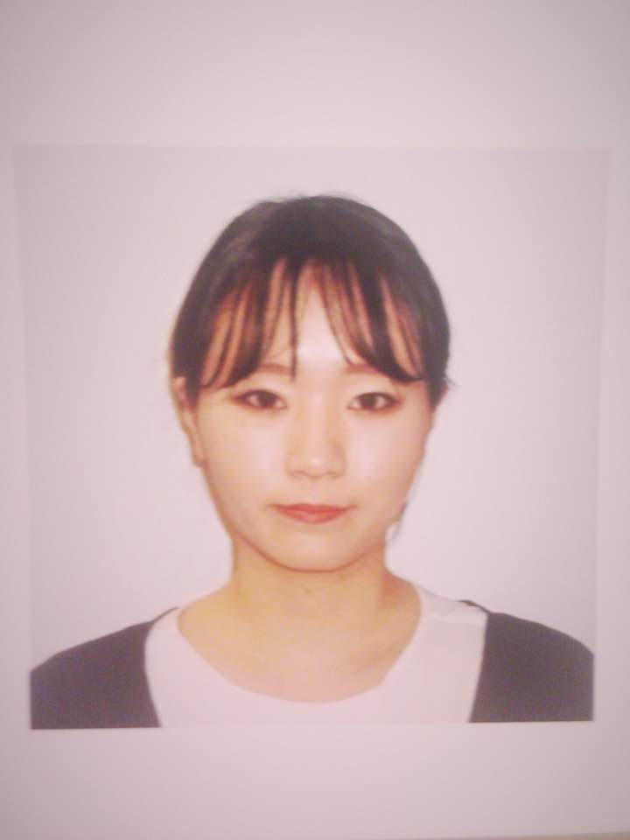

**Personal Information__________________________**

Nationality

Republic of Korea

Date of Birth

April. 24. 1994

Occupation

Student

**Education_________________________________________**

University of Rochester [2014- 2018]

Major in Business

Villanova Preparatory School [2009-2013]

Cum Laude graduate

California Scholarship Federation

**Professional Experience_______________________________**

Hacker’s Education Group [2013]

TOEIC Teacher’s Assistant

LongtuGame Co.- The E&M [2016]

Summer Internship- Strategic Planning Office

Main Tasks:

Strategic Planning for New Contents & Services

Market Research & Analytics

Used Programs:

MS Word

MS PowerPoint

**Other Experiences___________________________________**

University of Rochester

Rochester Korean Football Club (RKFC) - Manager [2014-2015]

Rochester Korean Baseball Club (RKBC) - Manager [2014-2015]

Korean Student Association

Villanova Preparatory School

Hogar Infantill Charity Club – President [2012-2013]

California Scholarship Federation - Qualified Member [2009-2013]

Girls’ Tennis Team – Varsity [2009-2012]

Girls’ Softball Team- Varsity [2010-2011]

Astronomy Club – Member [2009-2012]

**Proficiency_________________________________________**

Language

Native Language - Korean

Proficient Language – English

Other Skills

Microsoft Office

Dear Canon recruit team,

I am applying for your position in management/ strategic planning. I believe I am a strong candidate this position as I have qualifications and experience you are seeking.

After graduating from Villanova Preparatory School in California, I have been attending University of Rochester as an undergraduate student in business. This is my fourth year in college and I am planned to graduate this December. During my college years, I have acquired knowledges in marketing, public relations, business strategy, economy and rudimentary accounting. While taking my courses, I have developed insight in consumer behaviors and current marketing trends and grew a strong interest in strategic planning and costumer value creation. I had an opportunity to work at Longtu Korea, The E&M as a strategic planner last summer and as inspiring as it was, I wish to expand my learnings and experience and I hope to do so by working for Canon. Making the best out of my capability and knowledge I got from past internship, I believe that my skills will be both sufficient and helpful for the company.

Ever since I was a child, I was exposed to diverse cultures. I am currently living in Rochester, New York, graduated from a boarding schooling in California, and when I was a thirteen I lived with German family in Canada. My childhood is a bit different from others, as a little kid, jumping into a new environment alone was challenging and gave me difficult moments from time to time. But because I went through that experience and learned to survive it, I have grown in areas such as responsibility, communication skill and adaptability. Living in different countries helped me mature as an independent individual and co-existing member of a greater community. In fact, it has been told from my last internship that my social skills and accountable ability to complete given tasks are my best qualities. However, I am confident that my experience and knowledge qualify me for consideration. I look forward to meeting with you and bring forth good results.

Sincerely,

Joo Hyun Lee