R E S U M E
(Application date: 2017 . 05 . 21)
Basic Info. |  |  |  |  |  |  |  |  | 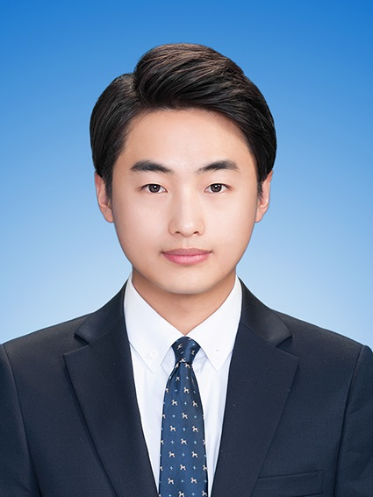
Name | (Korean) | 정 지욱 |  | Birth Date | 1989.08.222 |  | Age | 27
Name | (Chinese) | 鄭 志 昱 |  | Patriots/  Veterans | 2.No |  | Mobile  Phone | 01050527037
Current Address |  |  | 303-1405, 98, Sosadong-ro, Bucheon-si, Gyeonggi-do, Republic of Korea
TEL | 032-348-0585 |  |  |  | E-Mail | Eugine4224@gmail.com

Salary Requirements
Current Salary |  | (KRW) |  | Expectation | (KRW) 2400
Language | Test | Score / Level | Date | Reading & Writing | Listening & Speaking
English | OPIc | AL | 2017.02.26 | Fluent | Fluent
 |  |  |  | Fluent / Good /  Intermediate / Basic | Fluent / Good /  Intermediate / Basic

Educational Background
Period |  |  |  |  | Name of  High School/ College/ Univ. | Major | Average  Record) | Location | Remark
Year | Month | - | Year | Month
2005 | 03 | - | 2008 | 02 | Sangil-HighSchool |  | / | Gyeinggi-do | Graduated
2008 | 03 | - | 2016 | 08 | Myeong-ji University | Economics | 3.68 / 4.5 | Seoul | Graduated
 |  | - |  |  |  |  | /
 |  | - |  |  |  |  | /
ㆍ Blank period / Reason (Before / after graduation)  ㆍ Double major / Sub-major, etc. |  |  |  |  |  | Blank Period: Militray Service 2yrs, Internship & Exam 1yr  Double Major: Public Administration

Military service / Personal Info. |  |  |  |  |  |  | Certificate / License
Section | Completed |  |  |  |  |  | Name | Level | Institute
Army | Army | Class | Transport | Period | 2009.10.13 ~ 2011.08.07 |  | Computation  Accounting | 1 | KACPTA
Any handicap  of health & body |  |  | ( Handicap grade : ) |  |  |  | Mos 2010 | Core | Microsoft

Family Info.
Relation | Name | Age | Company | Title | Residence | Live together or not
Father | Jeong JungSeok | 55 | Real estate  leasing service |  | Seoul | X
Mother | Lee Yun-hee | 56 | Real estate  leasing service |  | Seoul | X
Brother | Jeong Jihong | 31 | Air Force | lieutenant | Sa-Cheon city | X

Career details
Period  (Year/Month-Year/Month) | Company Name | Employment Type | Department | Title
2016. 06 ~ 2016. 10 | Lotte KoreaSeven | Internship | Gyeongin 2nd team | Intern
Reason to Leave | The termination of contract
Detail  Job Responsibility | *Sales Management  - Data analysis including commercial and sales  - Planning and implementing promotional products related to priority products  - Transaction detail management  - CRM and CRM Channel Management  *SCM Planning  -Sync GIS with Sales Management
Period  (Year/Month-Year/Month) | Company Name | Employment Type | Department | Title
2011. 12 ~ 2012. 06 | Gyoza Harajuku | Internthip | Accounting | Intern
Reason to Leave | The termination of contract
Detail  Job Responsibility | * Financial accounting  - Remittance of funds  - Monthly balance calculation  - Establishment of funds plan  - Promissory note management  - VAT declaration and payment  - Settlement data entry  - Tax and utility payment  - Quarterly settlement
Period  (Year/Month-Year/Month) | Company Name | Employment Type | Department | Title
Reason to Leave
Detail
Job Responsibility

Job related training
Period |  |  |  |  | Training details | Provided by
Year | Month | - | Year | Month | Training details | Provided by
2015 | 03 | - | 2015 | 07 | Sales Strategies: Mastering the Selling Process | EdX
2016 | 02 | - | 2016 | 05 | Supply Chain Management | EdX
2016 | 08 | - | 2016 | 10 | Master Control in SCM | EdX
2017 | 01 | - | 2017 | 04 | System Design for SCM | EdX

Overseas experience
Period |  |  |  |  | Country | Purpose
Year | Month | - | Year | Month | Country | Purpose
2011 | 12 |  | 2012 | 06 | Australia | Internship & Volunteer

Self-Introduction
The motto of my life is “A rolling stone gathers no moss.” Just like this proverb presents, I’m very self-motivated person. Thanks to My Character I have made many personal developments. First, To Overcome my lack of experience in field. I worked for Two companies. Second, To get better communication skills I joined and actively participated in club activities. The last, For Deepening knowledge for economy I have become a regular subscriber of annual report written by Enterprise Institute and government agencies such as Bank of Korea or F.S.S.
Just like I described, my self-motivated character have made a lot of change. Indeed I learn things at lightning speed, To me a company is not the place for learning but the place for working, And this notion always makes me try to learn fast to perform my duties properly. Simply put I can clearly say that my character and experience will be useful during the internship with Canon Korea Consumer Imaging.

Applying Motive & Career Vision
The criteria what I have for choosing the company is possibility to contribute to society. So I naturally became interested in the digital image industry. Becase of the fact that Humans learn and obtain more than 70 percent of information through visual. So Digital imaging technology is a technology that contributes to the development of human beings. In addition to that Digital technologies like photography enrich human life as a hobby. Thus, the world's best digital imaging company, Canon Korea customization, is a suitable company for my standards.
What I want to accomplish in Canon is spread the value of Canon to more customers through successful management planning. Canon has delivered a message saying that photography is not only about the outcome but also the filming process. So I’d like to Plan the promotion such as the Media Art Special Exhibition held at Canon peulleksseu in 2010 to convey Canon's photography philosophy to more customers.

Strength & Weakness / Key achievement
Section | Details
Strength | *Analytic Skills  - MYSQL, SAP, DBeaver, ORACLE, SPSS, R, MS OFFICE, VEGAS, Photo#, QGIS ETC  *Communication Skills  -Expreince in conducting project which including co-work with Vendor and Associated department  *Work exerience  USQ project : planning and conducting offline promotion in Austrailia
Weakness | [Women who think too much]  This is the title of the book that allowed me to overcome my weakness. In the past, I used to worry needlessly. This book had help me to find the cause. Since the notion that which called Over-thinking causes a chain reaction. But this book explains how to use it positively. As a result, I have been practice to cause positive chain recation on one after another thinking
Key  achievement | - logistics project  In 2016, Was in charge of managing the product and manage the shipments with limited budgets. Thanks to effort to bulid regular trilateral meetings with vendors and related departments. I was able to reduce warehouse rental expenses and achieved over 90% Schedule compliance schedule.  - GIS Project  By syncing GIS with Sales management business efficiency has improved.

