JEONG JIN EUK
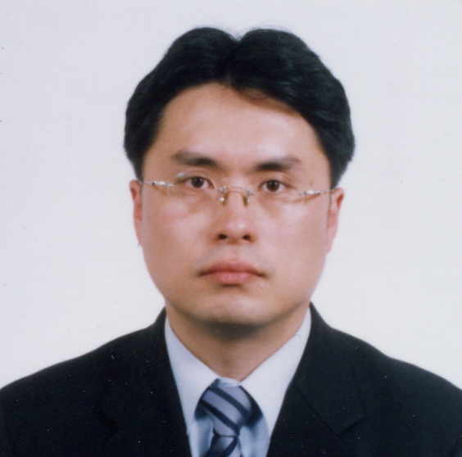
Name in Full: Jeong Jin Euk Desired Div : Marketing D
No. of resident registration : 731108-*******
Date of Birth: Nov, 8 1973/ Male/ Single
Address: 102-505 Hyusung apt. Gonrungdong Nowon-gu, Seoul, Korea, 136-831
Phone: 016-224-8561, (02) 915-7618 E-mail: donald8561@lycos.co.kr
Career Objective | Product Manager seeking new products in a consumer market
Summary Of Qualification | Product Manager of health food, OTC and Cosmeceutical Product
Experience | Product Manager (PM)  1999.3~2003.5 CKD (Chong Kun Dang Pharmaceutical Company)  ▶ Define/ Recommend New Product/ Business and Develop/ Implement plans for new product/ business with research of customer needs and product categories  ▶ Develop / Implement marketing plans  ▶ Educate sales staffs as a PM and managed  ▶ Coordinate/ Implement strategic cooperation with LG, Doosan  (OTC, Quasi Product (Mo&More, CareNic)  ▶ Planned and committed “Trade campaign” for pharmacist and  “Consumer promotion” for our target.  Product Manager (PM)  2003.5 ~2003.10 Bayer Korea  ▶ Define/ Recommend New Product for Canesten and Set up the aggressive advertisement plan for Aspirin Protect.  2003.10~ Redcaptour.Ltd.  ▶ Develop/ Implement plans for business with research of customer needs and product categories.
Education | 1992∼1999 Sejong University, Seoul, Korea  Bachelor of Science in Food Engineering
Computer Skills | ▶Strong computer skills  - Microsoft Excel, Word, PowerPoint, Hangul, Internet  ▶ Have working knowledge of all common office machines.
Language Ability | Good.
Interests | Movies, music and meeting people.
▶ Background.
Most pharmaceutical companies had expanded their business to consumer healthcare due to separation of dispensary from the medical practice in 1999. Chong Kun Dang had a lot of aggressive strategies to develop and launch new consumer products.
I was a new employee in charge of proceeding with theses projects at that time.

▶ Career.
For developing and launching safely some hair dyes and insecticides, I had focused on various ISM promotions based on some researches on needs of pharmacists and consumers
And I had proceeded with various activities of marketing and sales in not only Pharmacy, but also department stores and convenience stores. Besides, I just had participated in developing procedure for new products.

1. Moandmore
In Sep. 2004, I had been in charge of proceeding strategic alliance with LG.
Because I had been suddenly given its significant project, I had taken over Longkeybone Gold to other PM. The meaning of alliance with LG and CKD was that both companies exchange their products each other with using their own distribution channels.

The name of new product is “moandmore” for preventing hairs from falling out.
Because I had been told some information of other competitor’s new product launching plan, I was in need of newly differentiated promotion plan for safe launch at that time.

As launching program of moandmore, Cellular phone was provided complimentary and exclusively to consumers bought moandmore in pharmacies. Simultaneously I just conducted some advertisements like newspapers, TV, magazines.

Ad had emphasized the quality of this product with its own patent for some ingredients (5 alpha-reductase) preventing hairs coming off. Types of product were 3 classes - liquefied, shampoo and air massage. In case of air massage featured with convenience for use, it’s developed for young generation in the offices.
And to minimize price resistance, I had decided to fix middle price which is between the competitors’ prices based upon research.

To position as trusted product, I had used the picture of pharmacist demonstrated these products to consumers in the pharmacy for PR ad.
Through selecting excellent pharmacies, I had distributed some special membership sticker and various marketing materials presenting special-pharmacy for alopecia.

2. Longkeybone Gold
Longkeybone Gold was newly introduced to pharmaceutical market, which CKD (Chong Kun Dang) Healthcare had already formed in the name of kid nutrition and growth Market a few years ago.

In 2000 Sales volume for Longkeybone was about 30 billion won, however it’s getting losing its competitive advantages due to very disorganized distribution structures. This situation was so serious that it had given bad image to CKD.

Strategy for Longkeybone Gold had started form the idea that it would be very effective to launch pharmaceutical market instead of network place market. Because it’s very unique for pharmacist to directly recommend and explain Longkeybone Gold to consumer in pharmacy. At that time, I was confident of success of this product.

Based on the effect for stature of the existing “Longkeybone”, Longkeybone Gold had been reinforced with a few effective ingredients for “Eyesight Protection” and “Brain Development”
Package design was differentiated form other competitors. Package was wood, not paper and branded “Longkeybone Gold” with fire. I had carefully set up lower price than the existing Lonkeybone to minimize the price resistance of consumer. Regarding to distribution channel, it had been supplied to some limited pharmacies for price stabilization.

Sales volume was about 500 million won a month at that time and it’s evaluated as successful launching. Media of advertisement were newspapers and magazines with Slogan, “Swear of Mother”.
I had carried out lots of promotions for purchasing consumers and pharmacists, especially for provided sample on the counter in the pharmacy.

3. CareNic
A few months later, I had taken another new product of Doosan used for atopy
Through alliance with Doosan in 2001, new product was launched in the name of “CareNic” based on the atopy market research

One of the best competitive advantages in CareNic is Natural Ceramide playing an important role in regenerating skin and better than the existing other products maintaining moisture only.

According to the result of research on Atopians, they prefers more expensive product for new product if it works well. That’s why CareNic was set up with high price more than 30% than other products.
In addition to pharmacy, CareNic had chosen different distribution channels like clinics, major home shopping malls, online cosmetic shopping malls, etc. to get closer to consumers and had entered aggressively clinic market (dermatology, pediatrics..) to get directly excellent reputation form doctors.

I just had opened and supported lots of seminar on a national scale to announce the quality of CareNic to doctors and pharmacists. CareNic was divided into 2 parts. One is for pharmacy and the other is for clinic. So that had been very helpful to avoid conflict each other at that time.

Based upon the annual ad plan, I had put some ads in major newspapers (Chosun, Dong-a, Joongang), magazines and at the same time had hold big launching event through on –off line.
For example, Direct visit to clinic and pharmacy, on-line launching event, sample event, regular on- off DM, periodical monthly internet event..etc,

4. Summer’s Eve
Above and beyond these products, I was in charge of Summer’s Eve imported form C.B.Fleet from USA. This product was feminine wash. In regarding to this product, I had mainly focused on on-line marketing due to the character of feminine product.

5. Redcaptour.
Currently I’m in redcap tour and working in the marketing team.
Redcap tour is an affiliated company of LG and one of my acquaintances recommended me. So I just decided to move to this company. The reason I changed my career is that I usually want to learn consumer marketing.
I have built call center to provide better consumer service to consumer and increase sales volume. With constructing call center, I can manage and control call flow and improve consumer service quality of consultants.
Now I’m in charged of alliance with American Express and making its manual about American Express’s advanced operational techniques and introducing its excellent service to consumers.

I do hereby declare that the above statement to be true and correct in every detail.

