Gieun Jen Jeong
PERSONAL DATA
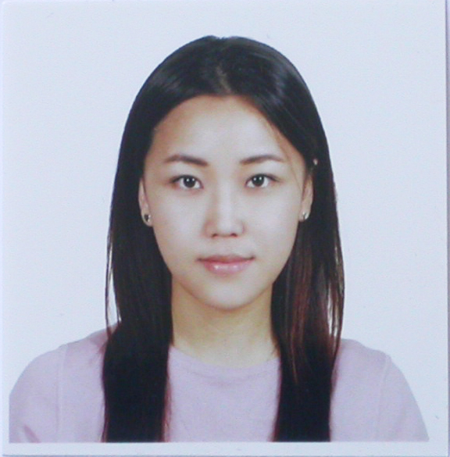
Date of Birth April. 06. 79
Address 732-32 201 Seocho gu
Banpo dong Seoul, Korea
Gender Female
Marital Status Single
E-mail jjegirl13579@hotmail.com
Contact 010-2354-0236
OBJECTIVE: To obtain a career that will best utilize my strong interpersonal abilities along with the opportunity for self advancement and growth.

SUMMARY
- Excellent communication and international experiences
- Ability to relate to foreign customers with an enthusiasm that generates confidence
- Experienced and capable of working in a diverse work force
- Detail oriented, flexible, and adaptable
- Successful working with people from multiple cultures
- Knowledge of Microsoft Word, Excel, Access, and PowerPoint
PROFESSIONAL EXPERIENCE
1. Todai Japanese Sushi and Seafood buffet Feb, 2006-Mar, 2007
- Sun Valley Mall D-214 Concord, CA 94520 (925)825-6265
Floor Manager.
- Designed a marketing strategy to increase revenue and market share
- Analyzed past customer statistical data and reported a new potential customer
- Created an efficient marketing plan to reach consumers
- Executed telemarketing and direct mail to customer
- Effectively managed the restaurant within the policies and guidelines of the company.
- Ensured maintenance of equipment, facility, and grounds via preventative maintenance
2. K Las Vegas convention Dec, 2004-Jan, 2006
3255 Las Vegas Blvd. S Las Vegas, NV (702)732.4888
Assistant manager
- Performed marketing and coordinated the event of trade show-CES
- International trade show – Managed Conference and meeting planning
- Prepared and presented proposals and conducted meetings
- Hired, trained and supervised the performance of over 50 volunteers in proper handling procedures of event

EDUCATION
University Nevada Las Vegas, Las Vegas, NV, U.S.A. Dec.2004.
Bachelor of Science in Hostel Management (3.21)
- GPA 3.68 2004 Fall President’s List
Relevant Courses:
- Hotel management Hotel Law
- Tourism and Convention Club management
- Labor MGT relations

AWARDS&ACTIVITIES
Volunteer
Customer Assistant: UNLVino April 2002 and May 2004
- Helped attends by answer questions
- Explained how the wines were made where the grapes from
- Promoted the wins and the University scholarship
Convention Exhibition representative: Las Vegas convention center(KOTRA)
- Assisted sales reps by answering questions as a translator
- Guided tour in Las Vegas
ASPECT ESL San Diego, CA 2001
SKILLS
Computer: Microsoft Office(Word, Excel, Power point)
Language: Fluent in written and spoken English and Korean
REFRENCES AVAILABLE

