R E S U M E
( Application date : 2007. 12. 16 )
Basic Info. |  |  |  |  |  |  |  |  | 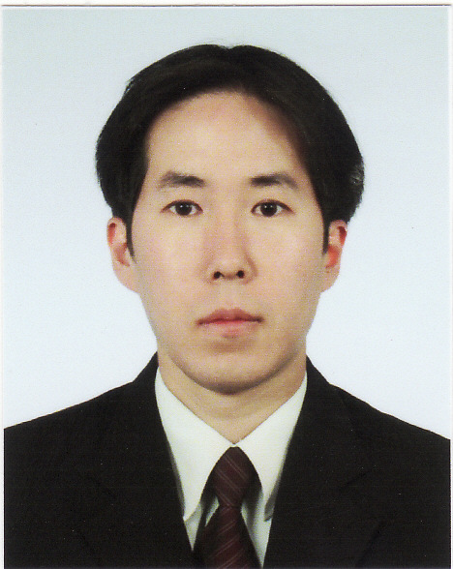
Name | (Korean) | 김학남 |  | Resident  Registration | 780127-1079615 |  | Age | 29
Name | (Chinese) | 金學楠 |  | Patriots/  Veterans | No |  | Mobile  Phone | 019-521-2564
Current Address |  |  | 502-11, Sung-nae Dong, Gang-dong Gu, Seoul, Korea
TEL | 02-477-3618 |  |  |  | E-Mail | gate17h@naver.com

Career history [ Total Career : year(s) month(s) ] |  |  |  |  |  |  | Desired Job / Language ability
Period |  |  |  |  | Company & Dept.or Team |  | Desired | Dept. | Position
Year | Month | - | Year | Month
 |  | - |  |  |  |  | 1st. Job | Service Center | Professional Rep.
 |  | - |  |  |  |  | 2nd. Job
 |  | -
 |  | - |  |  |  |  | Language | TEST Name | Record / Level | Date
 |  | - |  |  |  |  | English | TOEIC | 985 | Jul 23, 2006
 |  | -

Educational Background
Period |  |  |  |  | Name of  High School/ College/ Univ. | Major | Average  Record  (5.0 Conversion) | Location | Remark
Year | Month | - | Year | Month
93 | 03 | - | 96 | 02 | Pai-Chai High School |  |  | Seoul
96 | 03 | - | 03 | 08 | Yonsei University | English | 4.4 | Won-ju
 |  | -
 |  | -
ㆍ Blank period / Reason (Before / after graduation)  ㆍ Double major / Sub-major, etc. |  |  |  |  |  | After graduation – lived in U.S. for about 1 year

Military service / Personal Info. |  |  |  |  |  |  | Certificate / License
Section | Completed |  |  |  |  |  | Name | Level | Institute
Army | KATUSA | Class | SGT | Period | Jul, 1999 – Sep, 2001 |  | Word Processor | 2nd | KORCHAM
Any handicap  of health & body |  |  | ( Handicap grade : )

Family Info.
Relation | Name | Age | Educational background | Job | Company | Title | Residence | Live together or not
Father | Y.S. KIM | 62 | B.A. |  |  |  | Seoul | Yes
Mother | H.C. KWON | 61 | High School | Housewife |  |  | Seoul | Yes
Brother | H. J. KIM | 31 | B.A. | Association Staff | KICS | Asst. Mgr | Seoul | Yes
Career Introduction
(Application date : 200 . . )
Ⅰ. Applying motive & Vision | Applicant : HAK-NAM KIM
Applying motive

I have been deeply interested in camera and digital imaging products since I started my job-hunting. So when I saw your job ad, I got a hunch that this opportunity is very enchanting. That’s why I applied for ‘CKCI’.
Vision

If I have the chance to work for ‘Canon Korea Consumer Imaging’ to my great honor and fortune, I plan on being a competent ‘professional representative’ by providing my best service to the customers. Plus, I will devote myself to self-development such as taking second foreign language class and taking external educational programs.

As I am applying as an entrant, I admit that I got no hands-on experience, no proven track record, no expertise regarding camera industry. But I got huge confidence that I can get this job well done. So the bottom line is that I really want to be a high-performance staff at ‘Canon Korea Consumer Imaging’.

Ⅱ. Career details
Period |  |  |  |  | Company & Dept.or Team  Month | Job title | Role & Responsibility | Reason  to leave
Year | Month | Year | Month | Year
 |  | -
 |  | -

Ⅲ. Job related training
Period |  |  |  |  | Training details | Provided by
Year | Month | - | Year | Month | Training details | Provided by
1999 | 01 |  | 1999 | 06 | English Language Course | Collingwood Language School in Canada

Ⅳ. Competitive knowledge & Skill / Strength & Weakness / Key Achievement
(1) Competitive knowledge & skill |  | Applicant :
Section | Details
Language | I have superb command of verbal and written English.
Business Skill | I have outstanding interpersonal skill, which means I’m pretty good at dealing with customers efficiently.
PC Skill | I have excellent computer literacy such as MS-Office formats.

(2) Strength & Weakness / Key achievement
Section | Details
Strength | My strong points are that I am highly self-motivated, energetic and sociable. In addition, I am a good team player, which means I get along with people well.
Weakness | My weakness is that I get sometimes rushed at things. So I am always trying to unwind and take it easy to fix my weakness.
Key  achievement | For starters, my TOEIC score is 985 out of 990! Plus, when I attended university, I studied so hard that I could get my best honor’s award and scholarship thanks to my all A grades. Thank you.

